A1032-AM,C-Olmec-Jaguar Shaman-Jade-Classic Period 1100 CE

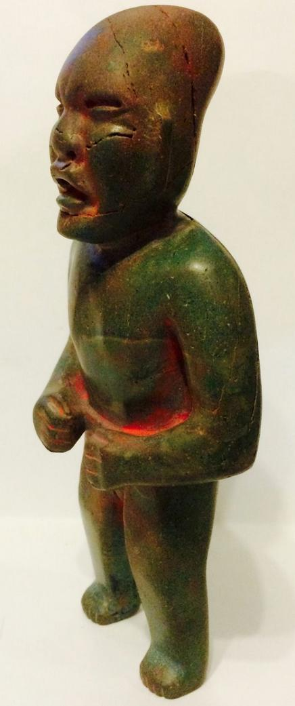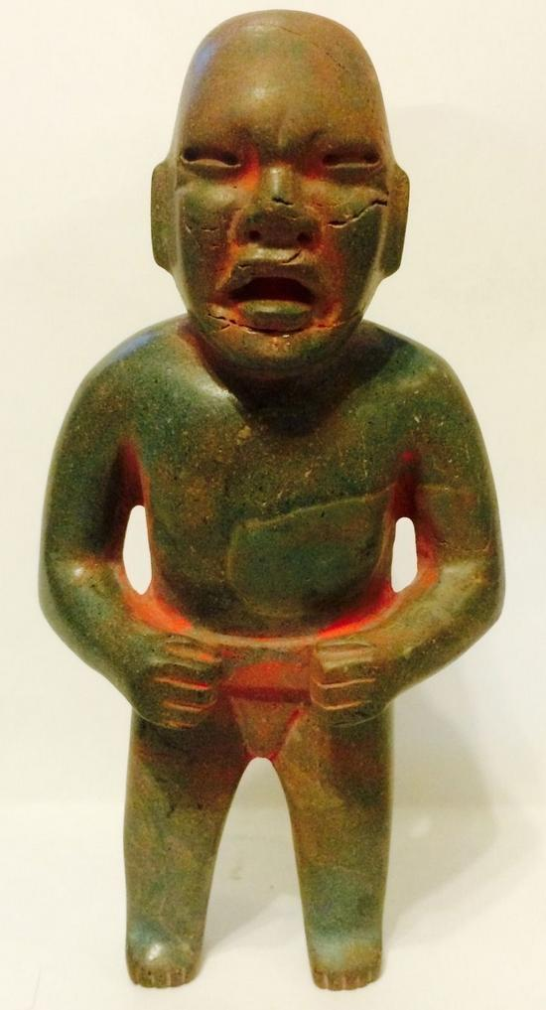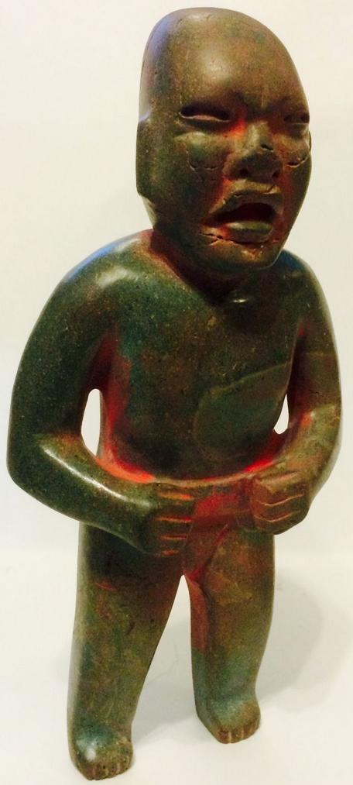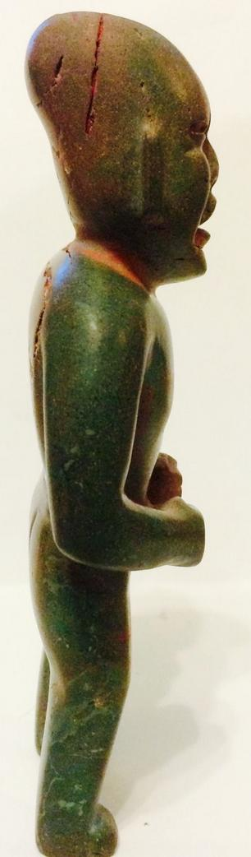

Pre-Columbian Olmec standing figure on jade found in Campeche in the early 60's and imported to the US. It depicts a jaguar shaman with an elongated skull on which traces of cinnabar have been applied in ceremonial activities. Erosion of the jade due to weathering is throughout the piece. It measures: height 6", depth 1 1/2", width 3".

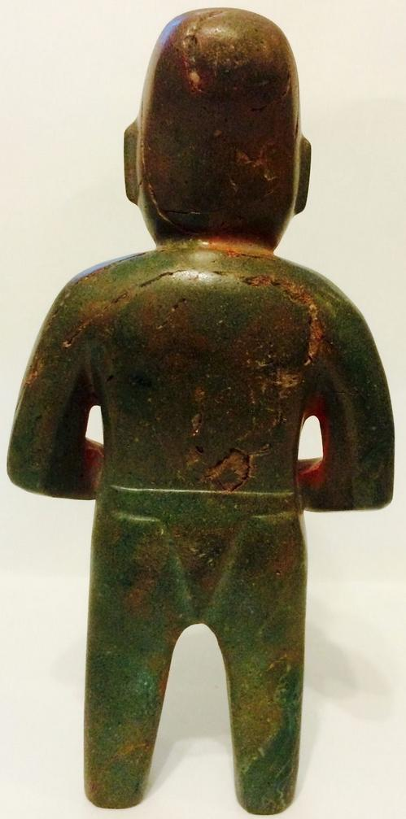

Sold by [eckbalam2012](http://myworld.ebay.com/eckbalam2012) ( [85](http://feedback.ebay.com/ws/eBayISAPI.dll?ViewFeedback&userid=eckbalam2012) )

### Delivery package 1 of 1

Estimated delivery Wednesday, Oct 7, 2015 - Saturday, Oct 10, 2015

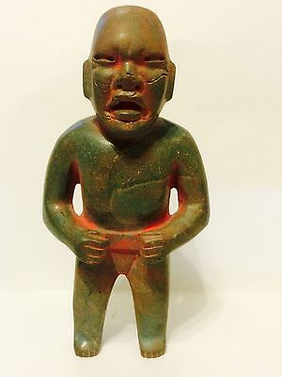

#### [Pre columbian Transformation Olmec green stone standing figure.](http://www.ebay.com/itm/271983678640)

|  |  |
| --- | --- |
| Item price | $2,000.00 |
| Quantity | 1 |
| Item number | 271983678640 |
| Shipping service | USPS Priority Mail |

## Shipping address

Ralph J Coffman Jr

149 Atlantic Ave

Swampscott MA 01907-2427

United States

## Order total

|  |  |
| --- | --- |
| Subtotal | $2,000.00 |
| Shipping | $6.40 |

**Total**

$2,006.40